**13 MODELLING DATA FLOW DIAGRAM**

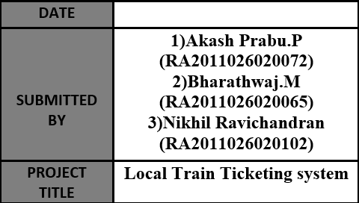 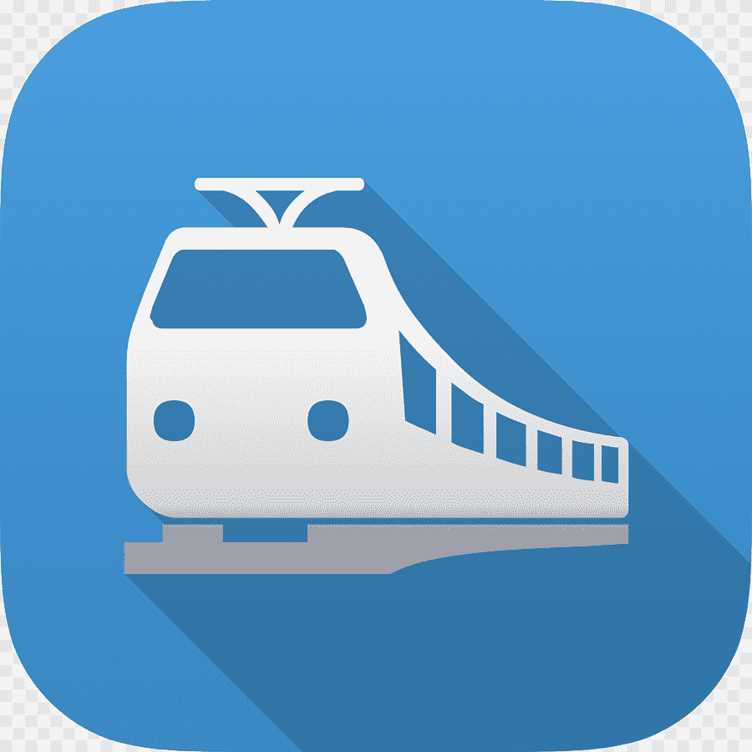

**13.1 DATA FLOW DIAGRAM DESCRIPTION**

**DATA FLOW DIAGRAM:**

DFD graphically representing the functions, or processes, which capture, manipulate, store, and distribute data between a system and its environment and between components of a system.

**COMPONENTS OF DATA FLOW:**

There are 4 basic symbols that are used to represent a data-flow diagram.

**1] PROCESS:**

Rounded rectangle represents the process, which receives input data and produces output with a different content or form. Processes can be as simple as collecting input data and saving in the database, or it can be complex as producing a report. Every process has a name that identifies the function it performs.

**2] DATA FLOW:**

A data-flow is a path for data to move from one part of the information system to another.

* Straight lines with incoming arrows are input data flow.
* Straight lines with outgoing arrows are output data flow.

**3] DATA STORE:**

A data store or data repository is used in a data-flow diagram to represent a situation when the system must retain data because one or more processes need to use the stored data in a later time.

* Data can be written into the data store, which is depicted by an outgoing arrow.
* Data can be read from a data store, which is depicted by an incoming arrow.

**4] EXTERNAL ENTITY:**

A rectangle represents an external entity. They are components outside of the boundaries of the information systems which either supply or receive data but does not process data. They represent how the information system interacts with the outside world.

External entities also are called **terminators** because they are data origins or final destinations.

An external entity must be connected to a process through a data-flow.

**13.2 DATA FLOW DIAGRAM**

